FRIDAY NIGHT BLUES JAM
@ the Bruthen Inn Hotel
Friday 16th Feb 2017 – 7.30pm to 12.30am

REGISTRATION FORM

The Bruthen Blues and Arts Festival Friday Night Blues Jam is an opportunity for keen amateur solo musicians and outfits to get up and play a short set to an enthusiastic blues festival crowd. Acts are judged on several aspects of their performances, and are in the running for several prizes including weekend festival passes and a paid set at the Blues Café on the Saturday night. Participants are encouraged to invite other artists up to jam with them (eg a singer/guitarist might invite a drummer and harp player to enhance their performance) – this can also serve to increase their score in the competition. The spirit of this event is a “jam” and “blues”, but artists are also judged on such aspects as their presentation, originality, delivery, crowd reaction, performance, entertainment value, style and skill. Solo artists and those performing towards folk or rock are still in the running, provided their songs are in the spirit of the festival.
Some simple rules apply:
- Strictly 2 songs per act (an artist might play one song solo, and invite others to jam for a second song)
- Spots are limited. Entries will be accepted until all places are filled.
- You will be notified that your application has been received and you have a confirmed spot.
- If there are any remaining spots, artists can register at the venue on the night for a chance to perform.

Contact Name:
Phone:
Email:
Act Name:
Instrument/s played:
Music genre/style/description:

If you would like other musicians to accompany you, please list who and/or which instruments:

Do you want to go in the running to win:
(please tick the relevant boxes – you can tick more than one)

☐ A paid set at the Saturday night Blues Café at the Hall
☐ A Festival Weekend Pass
☐ Other prizes
☐ Not competing for prizes, I just want to Jam!

APRA requirement: If you are able, please list details for the 2 songs you will perform:
 | SONG TITLE | ARTIST/COMPOSER
1
2

Email this completed form to evagrunden@bigpond.com
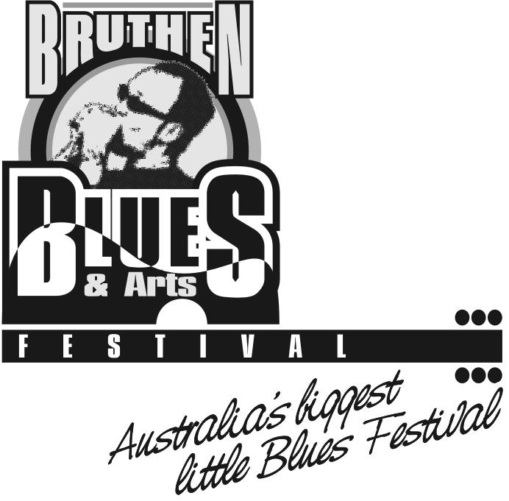
or post to: Eva Grunden, PO Box 150 Bruthen 3885

