Market Stall APPLICATION FORM Bruthen Blues and Arts Festival 2018
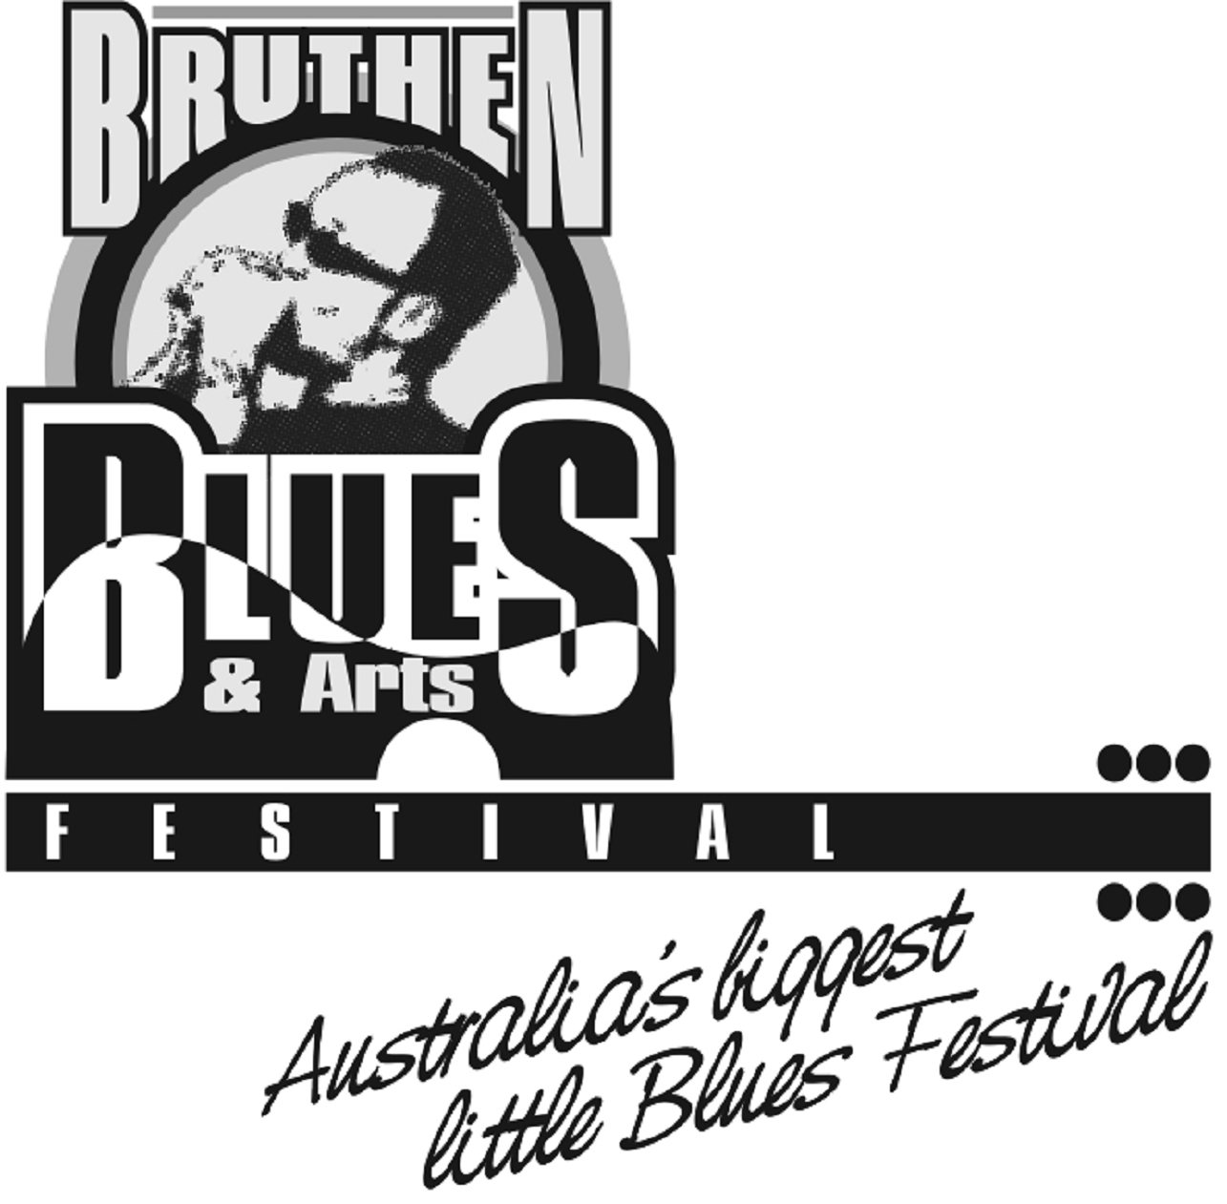
Bruthen Arts & Events Council Inc
PO Box 81, Bruthen Victoria 3885
www.bruthenblues.com.au

Thank you for applying for a market stall at
Bruthen Blues & Arts Festival
16th, 17th, 18th February 2018
Fill in your details below and have a read of our Terms and Conditions.
Please email form to Ellie at admin@bruthenblues.com.au
We’ll be in touch soon!

The shady environs of Bruthen's Main Street gardens are host to a street market on the Saturday and Sunday of the Festival. The stalls spaces extend into Ronald Street (a side street) and into the grounds of the Mechanics Hall.
Set amongst the market stalls is a live music street stage on the Saturday and Sunday, and also a Sunday gospel/blues service. These add to the attraction of the street scape and market atmosphere.
The market has up to fifty stalls, and we seek stalls such as musical, crafts, clothing, food and produce, quality second hand goods, children's items and activities, and other stalls that fit into the style and kind expected at a community music festival.

WHAT WE NEED TO KNOW ABOUT YOU…..

Contact Name

Stall Name

Phone Number

Address

Email

Website

(if applicable)

Car Registration

(see Terms and Conditions)

Brief Description of Your Stall

WHAT WERE YOU THINKING? (mark with an X)
Saturday - unpowered | $40.00
Saturday - powered | $50.00
Sunday - unpowered | $25.00
Sunday - powered | $35.00
SATURDAY + SUNDAY - unpowered | $60.00
SATURDAY + SUNDAY - powered | $80.00

DO YOU HAVE ANY OTHER REQUIREMENTS? Please describe…

Use of 2 sites? (fees apply)

Use of generator?

Other?

APPLYING FOR A MARKET STALL: TERMS AND CONDITIONS
- All applications will be considered.
- Payment must be made in advance. (please see website for directions)
- Receipt of payment must be shown on the Festival weekend.
- Food handlers must show their permit from the Shire/Food Handling Certificate.
- Stallholders are responsible for the Public Liability Insurance for their own sites and goods.
- Saturday Market starts at 10am and finishes at 5pm.
- Sunday Marketing starts at 9am and finishes at 2pm.
- There will be road closures in place. Given this, Market Stalls must be set up and vehicles moved from the stall sites by 9.30am Saturday and by 8.30am Sunday
- Stallholders should arrive no earlier than 7.30am, after which time the Market Coordinator will direct you to your site.
- Site locations will be already allocated, so early arrival will not create any advantage.
- Site sizes for this market will be 3.2 metres x 3.2 metres. Stallholders with set-ups that are larger than this area will need to purchase an additional site.
- The market is held in the public main street of town. Stallholders are responsible for their stall security overnight.
- No refunds will be given for non-attendance
- It is important that all dogs, including those sitting with their owners at a market stall, are kept on a lead at all times.
- We will make our best efforts to accommodate stallholders’ needs regarding location, space, power, etc.
- Some details and time frames may change without notice, at the discretion of the Committee
- Stall holders who contradict any of the requirements or conditions will be requested to leave, at the discretion of the Committee

- By applying for a stall, you are lodging an expression of interest with the Market Committee. Your application will be considered, and you will subsequently be advised if you are successful. Market stalls are selected by the committee to fit with the family-friendly and community-focussed experience of the festival.
- There will be road closures in place. As such, Market Stalls must be set up and vehicles moved from the stall sites by 9.30am Saturday, and by 8.30am Sunday. Stallholders should arrive no earlier than 7.30am, after which time the Market Coordinator will direct you to you site.
- Site locations will be already allocated, so early arrival will not create any advantage. Site sizes for this market will be 3 metres x 3 metres. Stallholders with set-ups that are larger will need to purchase an additional site.
- Regarding (particularly) food vendors: each will be considered by the committee. Priority is given to existing town vendors and local vendors who already sponsor, participate or contribute to the community. Your application may not be accepted because there is already a food vendor providing similar food and drinks.
- Some kinds of stalls may be considered inappropriate for the festival given the festival is a family-friendly, community-focussed, music event. The committee's decision to accept a stallholder's application is based solely on factors that best meet the needs of the festival, their decision is final, and any correspondence regarding an appeal may be considered at the discretion of the committee.
- We are a community-based event aiming for a friendly and easy-going festival market experience for our patrons. Due to occasional problems in previous years regarding stall placement, and some stallholders becoming demanding, argumentative and abusive towards our volunteers, there will be a zero tolerance policy for such behaviour. The committee holds the permit for the market, and if required will exercise our right to evict any aggressive or inappropriate stallholders.
- Limited electrical outlets are available near to the Mechanics Hall. We will make efforts to accommodate those requiring a powered site. Electricity is not available in the street garden area. The use of generators is discouraged. If you need to use a generator, you must advise us in your application. We expect any generator not to impact on the enjoyment of the festival-goers. This includes noise and pollution considerations.
- Stallholders will be fully responsibility for the presentation, safety and management of their stalls. The stall holder is wholly responsible for the quality of their product, and the Festival Committee will not be held responsible for loss, damage or breakage of stall infrastructure or products.
- The sale of dangerous, anti-social, illegal or offensive items including pornography, drug paraphernalia or weapons (either genuine or replica) is prohibited.
In the event that all or part of the festival is cancelled due to emergency conditions (fire, etc.), fees relevant to the cancelled days will be refunded, provided sufficient applicant details have been provided...

THANK YOU! You will hear form us soon!
From us, the Bruthen Blues and Arts Festival Committee

