Thank you for considering volunteering for the
Bruthen Blues & Arts Festival
18th, 19th and 20th February 2022

Bruthen Community is very proud of the Bruthen Blues and Arts Festival and we are excited to be back for 2022 after having to cancel the last 2 festivals, firstly due to bushfires and then this year due to the threat
of Covid 19. This one will be extra special because it is the 25th Festival. It will have all the favourite as-
pects of previous festivals but is going to look a little different to meet any Covid restrictions. That will
mean that we will need more volunteers to make it all happen. So please consider helping out.
The Blues planning committee has been volunteering their time in the months of planning leading up to
the festival. On the weekend of the Festival we need volunteers to make sure it all comes together. For your effort, you will receive free admission to some or all of the events over the weekend, depending on
how much time you donate.
• 4 volunteer hours - Passes to one event at the hotel. (Or your choice)
• 6 volunteer hours—Passes to two events at the hotel. (Or your choice)
• 8 Volunteer hours—Passes to all events at the hotel. (Or your choice)

Some examples of the work you might be asked to do:-

In the weeks before the Festival:
 Fold and distribute programs and posters.
 Putting together artists info packages etc.
 Putting up barriers and fencing.

On the weekend of the Festival:
 Help setting up and packing up venues over the weekend.
 Putting up street decorations.
 Help venue managers at the door of an event.
 Sell raffle tickets, merchandise etc.
 Help with setup and changeovers at the Street Stage.
 Help out at the Street Parade and the Duck Race held on the Sunday (carrying props,
acting as "duck wrangler", "duck catcher", "duck race judge" etc)
 Helping to clean up and pack up after the festival.
 Helping at the festival information stand.
 Parking marshals.

To register as a volunteer please fill out the details below, and email to bruthenblues@gmail.com.au
Or mail to Bruthen Blues & Arts Festival, Box 81, Bruthen VIC 3885

The Bruthen Blues and Arts Festival is an event presented by the Bruthen Arts and Events Council Inc. Follow us on
Facebook at Bruthen Blues and Arts Festival or checkout our website at www.bruthenblues.com.au

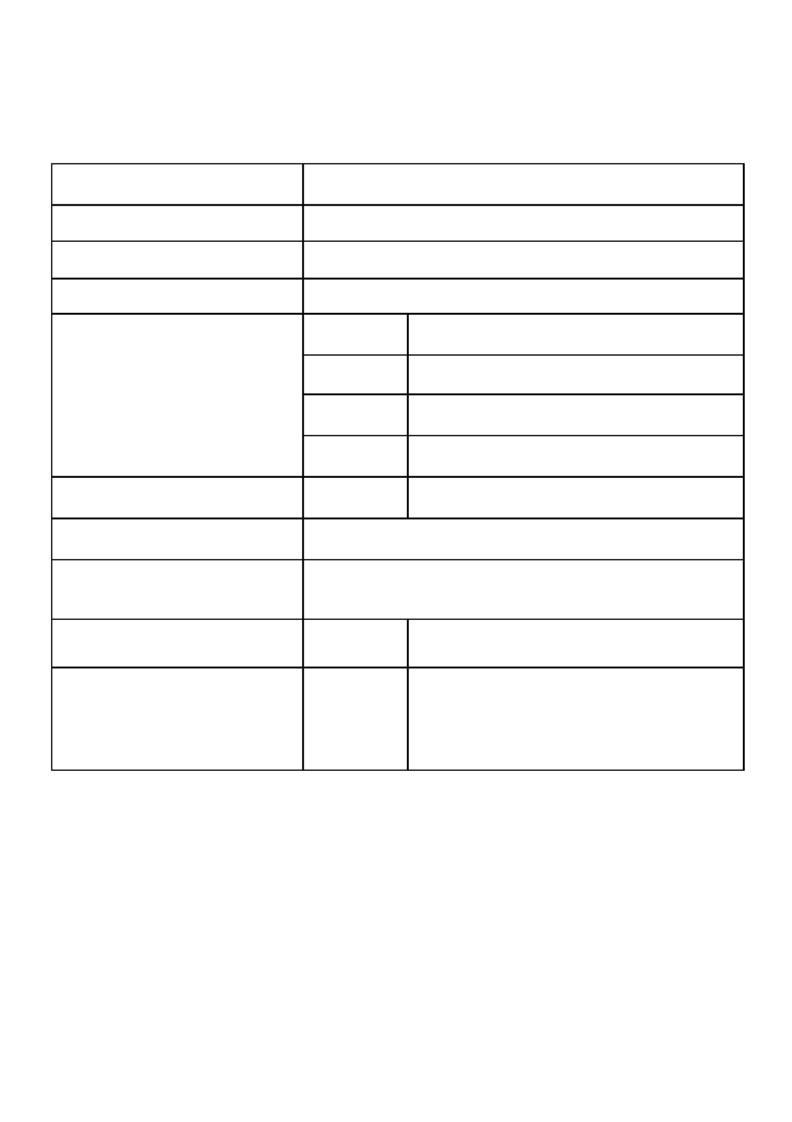
Bruthen Blues and Arts Festival
VOLUNTEER APPLICATION FORM

Volunteer Name

Postal Address

Phone Number

Email Address

What days are you available?

How many hours will you volunteer for?
Would you like to help with planning the
festival?

What activities would you like to
volunteer for? (See previous page).

Have you completed the online Covid
Marshal training?

Do you have a medical condition that
may affect your volunteering ? If so
please specify. Eg, Unable to stand for
long periods of time.

Friday 18th

Saturday 19th

Sunday 20th

Monday 21st

Activity:

Yes/No

Yes/No

NB If so you will need to show our volunteer coordina- tor your certificate.
Details:

I agree that all of the information provided on this form is correct.
I agree that I while volunteering at the Bruthen Blues and Arts Festival I will follow any in-
structions given to me by the volunteer coordinator or their representative. I will also
comply with current Covid 19 restrictions.

Signed:
Date:

Volunteer coordinator Signature:

